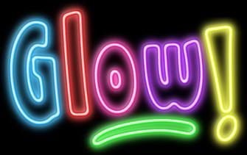
Event Night Prices:
Members: $10 per child
Non-Members: $15 per child
*Restrictions apply:
No passes & No make-up classes

June 13th, 2018
GLOW PARTY
5-6PM
Summer Event Night $10 per child for members $15 per child for non-members
Come Join Us for one free Glow Bracelet and lots of fun in the gym.
We will have a glow tunnel with black lights, glow balloons, games, and more fun!
*Restrictions apply: No passes, No make-up classes

June 20th, 2018
School Year Class Sign-Up
OPEN PLAY
5-6PM
Summer Event Night $10 per child for members $15 per child for non-members
Sign-Up Tonight For School Year Classes and receive one free open play pass for the school year 2018-2019. As you are signing up for classes join us for our summer Event Open Play and play in the gym with the coaches.
*Restrictions apply: No passes, No make-up classes
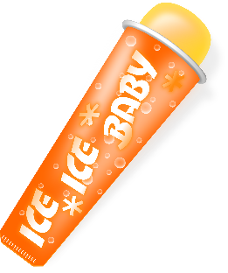
June 27th, 2018
POPSICLE NIGHT
5-6PM
Summer Event Night $10 per child for members $15 per child for non-members
Join us for playing in the gym 5:00-5:50pm and one free popsicles outside 5:50-6:00pm.
*Restrictions apply: No passes, No make-up classes

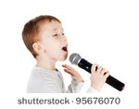
Event Night Prices:
Members: $10 per child
Non-Members: $15 per child
*Restrictions apply:
No passes & No make-up classes

July 11th, 2018
KARAOKE PARTY
5-6PM
Summer Event Night $10 per child for members $15 per child for non-members
Do you like to sing? Join us for play in the gym and a chance to share your singing talent.
*Restrictions apply: No passes, No make-up classes

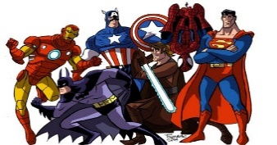
This Photo by Unknown Author is licensed under CC BY-NC-ND
July 18th, 2018
Super Hero Costume Contest
5-6PM
Summer Event Night $10 per child for members $15 per child for non-members
Dress-Up as your favorite super hero and come play in the gym. Costumes will be judged at 5:10pm for our favorite and winner will be announced at 5:55pm.
*Restrictions apply: No passes, No make-up classes

June 25th, 2018
GLOW PARTY
5-6PM
Summer Event Night $10 per child for members $15 per child for non-members
Come Join Us for one free Glow Bracelet and lots of fun in the gym.
We will have a glow tunnel with black lights, glow balloons, games, and more fun!
*Restrictions apply: No passes, No make-up classes

